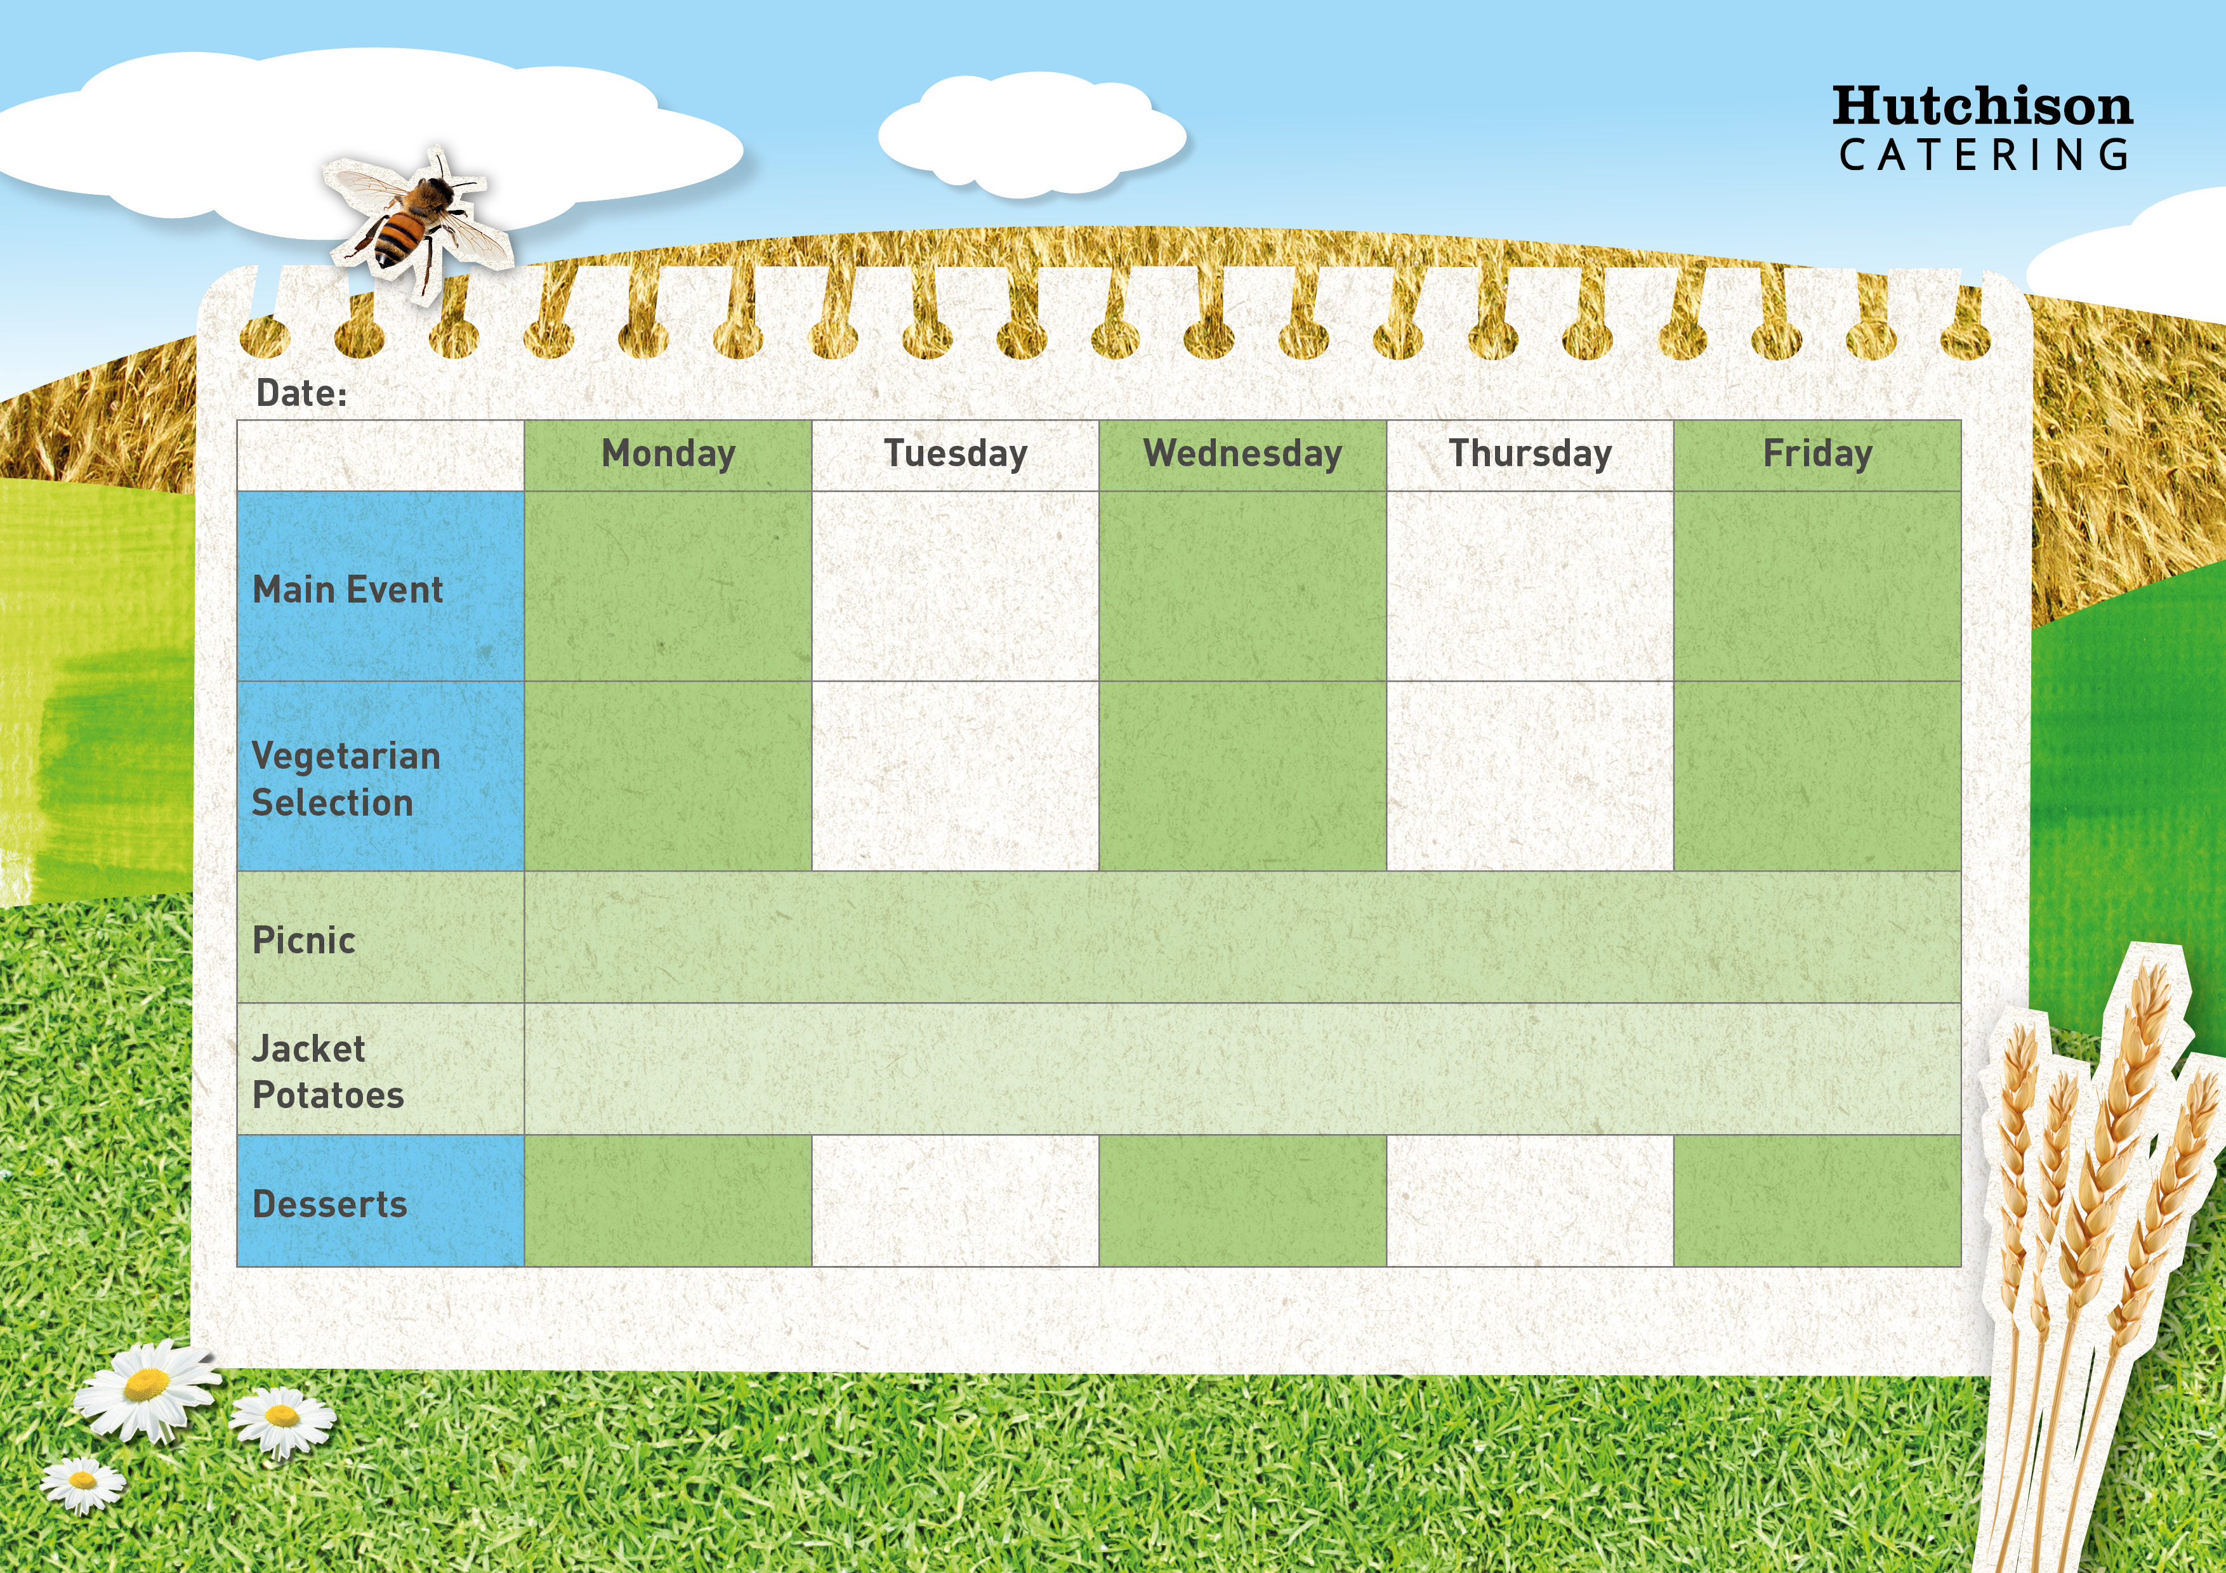

Vegetarian Bolognaise with Broccoli and Garlic Bread

Margarita Pizza with Herby Diced Potatoes & Sweetcorn

Spaghetti Bolognaise with Broccoli and Garlic Bread

Chicken Taco with Rice and Sweetcorn

Quorn Taco with Rice and Sweetcorn

**Available Daily:** Fresh Bread, Water, Fresh Fruit and Yoghurt

Chocolate Shortbread

Ginger Biscuit with Fruit

Fruit in Jelly

Sticky Toffee Pudding

Jam doughnut muffins

**Crispy Baked Jacket Potato with a Choice of Fillings, Mixed Salad**

**Dessert of the Day or Fresh Fruit**

**Freshly Prepared Sandwich, Wrap or Baguette, with Mixed Salad, Healthy Snack,**

**Dessert of the Day or Fresh Fruit**

Quorn Nuggets with Chips & Baked Beans

Roast Quorn Fillet with, Mash Potatoes, Carrots, Yorkshire & Gravy

Crispy Battered Fish with Chips & Baked Beans

Roast Chicken with, Mash Potatoes, Carrots, Yorkshire & Gravy

BBQ Chicken Pizza with Herby Diced Potatoes & Sweetcorn

**Autumn Week 3**