Dear Parents and carers,
It has been another busy week with many visitors coming to school to support us. Thank you to Linda Bailey our PSCO for delivering an informative Online Safety assembly and to the Mad Science Company for showing us what their after school club involves.
Free online courses:
Cheshire College – South and West is offering a range of accredited short training courses at Level 2 that can be undertaken online, at the learner’s convenience.
Please click on the icon to see details.
Half Term Holiday Club
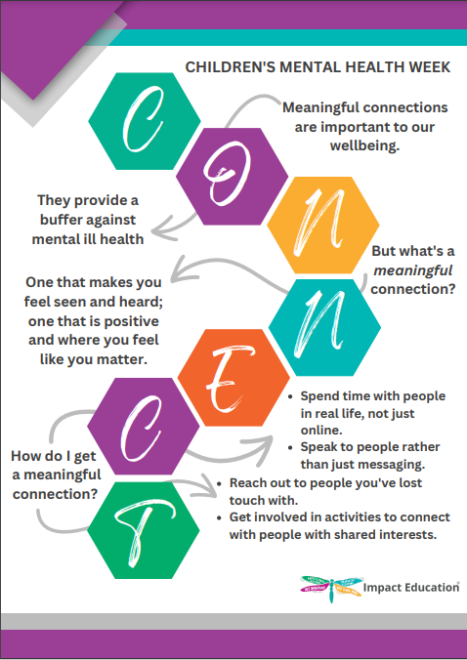
Children’s Mental Health Week
Next week we will be focusing on Children’s Mental Health week. Teachers will be providing opportunity for discussion and activities. Please find time to talk to your child and share resources together. Our school website has many links for well being support.

Have a lovely weekend
Mrs Lyon & Mrs Cox

